ASCENDIATE WEBSITE REFINEMENT
PURPOSE
- My aim is to distinguish between what is working and what needs to change to align with the brand I have developed as the website has been constructed.
- This document is not meant as a redesign but rather as a refinement.
- The underlying structure is strong, but I think the brand itself has evolved during the design process.
- The website should now position Ascendiate as a broader strategic advisory platform, with aviation becoming evidence of that proposition rather than the proposition itself.
- The comments below are intended to help guide refinement.

EDITORIAL COMPOSITION
- Having reviewed the website as a whole, I think it would benefit from a more deliberate editorial composition from section to section.
- This comment relates to the overall visual composition of each section rather than the underlying design language. The typography, colour palette, spacing and overall visual identity should remain consistent throughout the website.
- Rather than repeating the same composition throughout, I would like the eye to move naturally across the page as the user scrolls.
- Subject to the content of each section, would like the website to adopt the following editorial composition:
Hero |  | text left image/graphic right
About | Challenge | image/graphic left text right
 | Route forward | text left image/graphic right
 | Ascendiate | image/graphic left text right
Approach | Mandate | text left image/graphic right
 | Opportunity | image/graphic left text right
 | Ascendiate | text left image/graphic right
Mandates  (formerly Experience) |  | central architectural focal point with supporting examples arranged to create a natural editorial flow
Contact | No change
- I think this creates a much stronger sense of progression, prevents the website feeling repetitive and establishes a more engaging reading experience whilst maintaining a consistent visual identity.
- The objective is not simply to alternate text and images. It is to create a deliberate editorial rhythm that guides the reader naturally through the narrative of the website.

GENERAL OBSERVATIONS
- I think the website has a clean, premium foundation and a restrained visual style that suits the brand.
- Having reviewed the website multiple times, it currently feels more descriptive than editorial.
- The content is generally strong, but the presentation does not yet create the sense of clarity, confidence and sophistication that I think the brand should be communicating.
- The overall objective should be to create a website that feels calm, thoughtful and authoritative.
- At every stage, the guiding filter should be that the viewer thinks: I should speak to this person.
- The objective throughout should be to communicate confidence through restraint. Where there is a choice between adding and removing, I would generally prefer the latter.

TYPOGRAPHY AND EDITORIAL HIERARCHY
- This is the single biggest area I wish to revisit.
- Currently, there is not enough visual hierarchy between headings, supporting statements, sub-headings and body copy.
- As a result, the pages appear more text-heavy than they actually are.
- Please could you ensure that there is greater differentiation in typography, spacing and placement so that the eye naturally moves through the page.
- Please use the following general editorial principles:
  - Supporting statements should ideally remain within two lines.
  - Paragraphs should communicate a single idea before breaking.
  - If copy becomes too long, please let me know so that I can simplify the wording rather than reducing the font size.
  - Greater consistency should be applied to the positioning of headings, supporting statements and content throughout the site.
- I would like the typography to become one of the defining characteristics of the website.

NAVIGATION SECTION
- Please change Experience to Mandates.
- No further comments.

HERO SECTION
General
- This remains the strongest section of the website and I would like to retain its overall composition.
- In particular, I like the light/dark contrast, the restrained layout and the prominence given to the headline. I think these establish the right tone for the brand.
- Having reflected on it, however, I think this section should evolve to reflect how the Ascendiate proposition has developed.
Positioning
- The website should no longer position Ascendiate primarily within aviation.
- Instead, it should present a broader strategic advisory proposition, with aviation becoming evidence of that proposition rather than the proposition itself.
- This section should:
  - feel equally relevant whether the visitor comes from aviation, private equity, infrastructure, industrials or another complex business environment; and
  - feel equally compelling whether the visitor is a CEO, chairman, investor or founder in aviation or any other complex industry.
Presentation
Please see rough visualisation below.
Content
Please update as follows

Eyebrow /introductory line
Delete: Trusted partner to leadership teams.
N.B. No eyebrow needed as headline is doing heavy lifting.

Headline
Keep: Shaping vision into value

Supporting description
- Delete: Guiding strategic transactions, restructurings and operational improvement across the aviation sector
- Replace with: Independent judgement that aligns priorities, shapes decisions and leaves organisations stronger.

CTA
- Delete: Experience
- Replace with: Mandates

Imagery
- I have considered the current image several times and do not think it fully communicates the qualities I want the brand to convey.
- The issue is not the quality of the image but the message it communicates.
- The current image feels rooted in aviation, technology and digital networks.
- As the positioning has broadened, I think the imagery should instead communicate independent judgement, integration and clarity.
- Rather than illustrating movement or travel, I would like the imagery to communicate the integration of multiple perspectives into coherent direction.
- The strongest references, for me, are contemporary architecture, geometry, structure, light and materiality. The overall impression should be calm, premium and editorial rather than technological or futuristic.
- I have attached some reference images which are intended to communicate the mood and direction rather than provide designs to replicate (the ideas and colour palette may need some work).
- I am particularly drawn to (in order):
  - C2
  - A2
  - C3
- I think they better communicate structure, integration and considered judgement while remaining understated and timeless.

Rough visualisation (idea only)

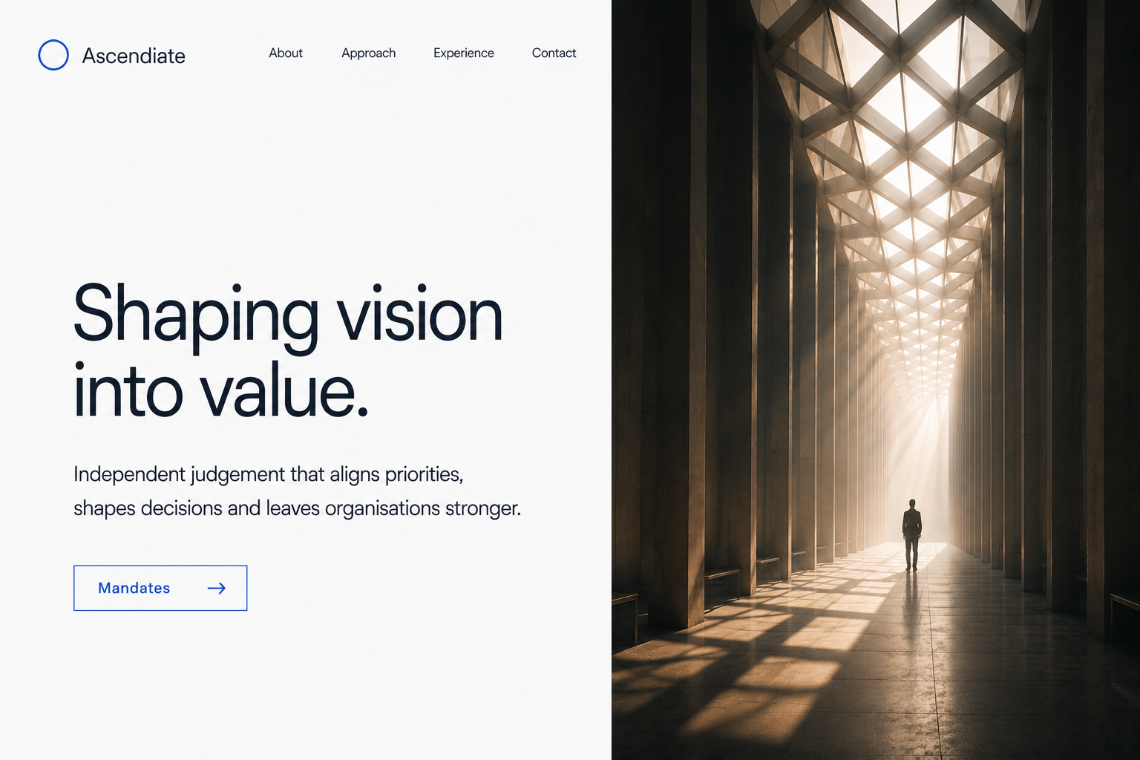
N.B. Intended to communicate hierarchy, composition and editorial rhythm only. They are not intended to prescribe typography, spacing, imagery or final design
ABOUT SECTION

General
- I think this is currently section of the website requiring the most design presentation refinement.
- The section currently feels more like a report than a premium editorial website.
- I would like this section to communicate the same confidence, restraint and clarity established by the Hero section.
Positioning
- This section should introduce the thinking behind Ascendiate rather than explain the business.
- The objective should be to create understanding progressively, allowing the reader to discover the philosophy through editorial hierarchy rather than large blocks of text.
- Rather than presenting information as consecutive paragraphs, I would like each idea to have a clear visual anchor, with supporting text unfolding naturally beneath it.
Presentation
- This section should move away from a conventional report-style layout and adopt a much stronger editorial hierarchy.
- The hierarchy between section headings, lead statements and body copy is currently too compressed, making the page appear denser than it actually is.
- I would therefore like a much greater distinction within the supporting statement:
  - section heading;
  - lead statement;
  - supporting text; and
  - body text.
- The lead statement should immediately draw the eye, with the supporting copy naturally unfolding beneath it. The objective is that the reader always knows where to begin.
- The supporting copy should be broken into shorter editorial paragraphs rather than continuous blocks of text. Each paragraph should communicate a single idea before moving to the next.
- Having experimented, I think subtle horizontal dividers work here. Rather than acting as obvious separators, they create gentle editorial pauses that improve reading rhythm and reduce the feeling of dense text.
- Overall, the section should feel considerably lighter, calmer and more premium without materially reducing the underlying content.
- The section should not present the three supporting statements as stacked text blocks. I would like the layout to create a consistent diagonal editorial rhythm (as set out above in Editorial Composition).
- This is intended to break up the text visually, create movement through the section and avoid the page feeling like a report, while keeping typography, colour palette, spacing and overall visual identity consistent.
- The emphasis should be on editorial hierarchy rather than content density. Lead statements should dominate each content block, with supporting copy and body text progressively reducing in visual prominence.
- Please see rough visualisation below.

Content

Headline
Keep: About

Supporting statement
Keep: Creating, growing and stabilising businesses. Building stronger organisations

Note: The following wording should be regarded as content rather than layout. Typography, hierarchy, spacing and editorial presentation should be developed independently to create the strongest possible reading experience

Section heading | Challenge
Lead statement | Organisations operate in constantly evolving environments.
Supporting text | Priorities shift. Organisations grow. Markets change. New challenges emerge.
Body text | As objectives evolve, organisations do not always adapt at the same pace.  The expertise and perspectives needed to respond rarely sit in one place. They are often shaped by competing priorities and constraints.

Section heading | Route forward
Lead statement | Achieving successful outcomes requires more than expertise alone.
Supporting text | Priorities compete. Constraints emerge. Decisions become harder. Opportunities are missed.
Body text | Achieving those outcomes begins with understanding what leadership is seeking to achieve and what may be preventing progress.  Reconciling divergent priorities and constraints creates direction, builds momentum and delivers tangible results.

Section heading | Ascendiate
Lead statement | Delivering today’s objectives. Strengthening tomorrow’s organisation.
Body text | Ascendiate is an independent platform that transforms competing priorities into clear direction and momentum.  Its value lies not only in achieving today’s objectives, but also in building the organisational capability required to address tomorrow’s challenges.

Imagery
- I do not think the current graphic supports either the quality of the content or the overall brand.
- It currently feels too much like a presentation graphic or consultancy diagram rather than an integral part of a premium editorial website.
- The imagery should exist to support the typography. The typography should remain the dominant design element throughout the section.
- The imagery should communicate structure, integration, perspective and considered judgement without attempting to illustrate the text literally.
- Similar to the Hero section, contemporary architecture provides the strongest visual language. I would like the imagery throughout the website to feel part of the same editorial family.

Rough visualisation (idea only)
Challenge section only:
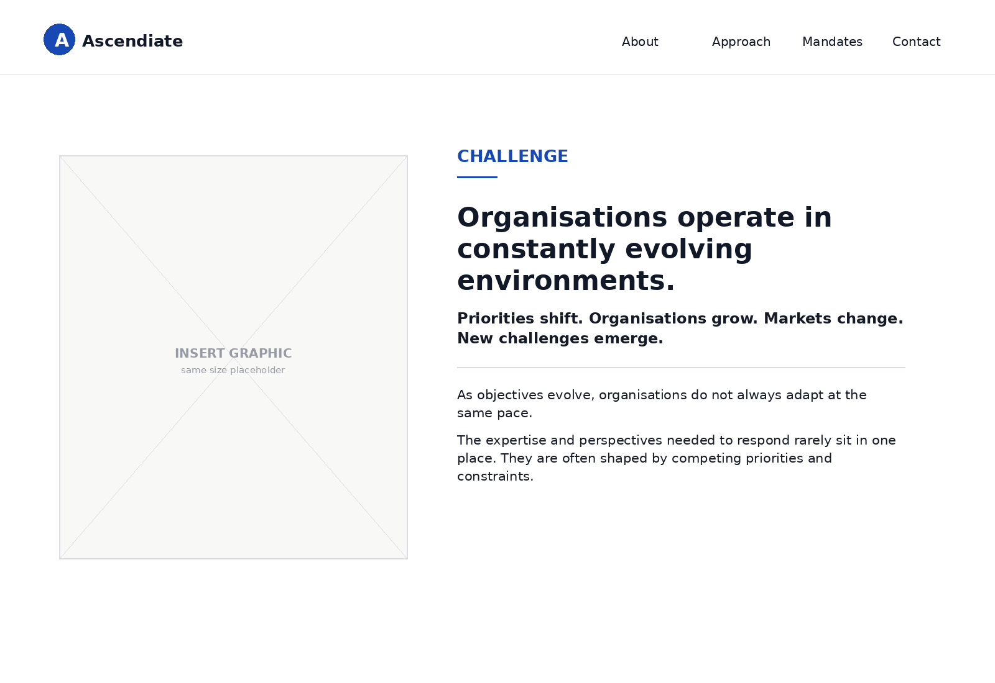

N.B. Intended to communicate hierarchy, composition and editorial rhythm only. They are not intended to prescribe typography, spacing, imagery or final design

Entire section:

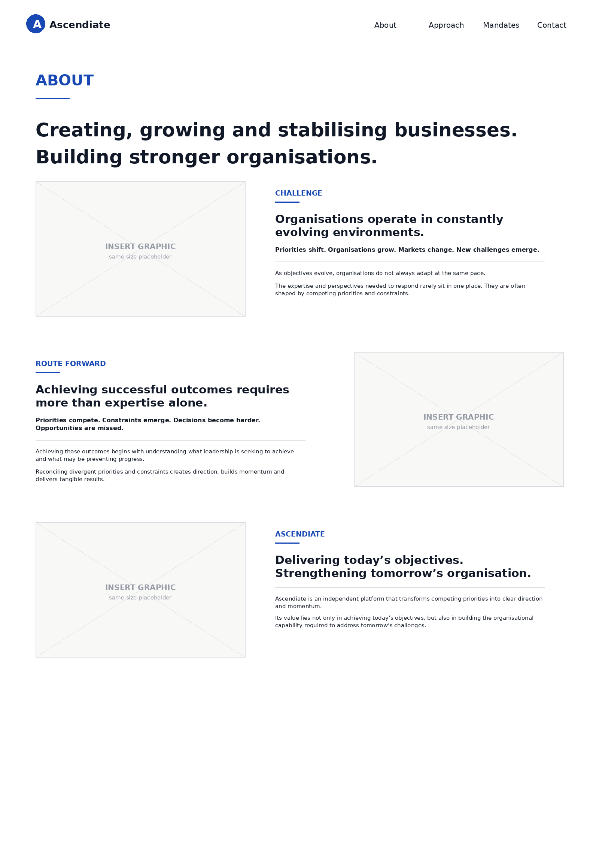
N.B. Intended to communicate hierarchy, composition and editorial rhythm only. They are not intended to prescribe typography, spacing, imagery or final design
APPROACH SECTION

General
- I think this section should evolve in the same way as the About section. Rather than explaining a methodology or process, it should explain how Ascendiate creates additional organisational value.
- The objective should be to guide the reader logically from the immediate mandate, to the broader organisational opportunity and finally to Ascendiate.
- Similar to the About section, the content should progressively build a single proposition rather than present a series of independent ideas.
Positioning
- This section should explain how significant mandates become opportunities to strengthen organisations.
- Rather than presenting a consulting methodology or legal process, it should demonstrate the thinking that underpins Ascendiate.
- The reader should feel that the philosophy develops naturally from the preceding sections rather than being presented as a sales proposition.
- By the conclusion of the section, the reader should understand not only how additional value is created, but also why Ascendiate is uniquely positioned to deliver it through the experience and judgement of its Founder and Managing Director, Nicholas Zaklama.
Presentation
- Similar to the About section, I would like this section to adopt a much stronger editorial hierarchy.
- The section should comprise three clearly differentiated editorial blocks:
  - The Mandate
  - The Opportunity
  - Ascendiate
- Each editorial block should comprise:
  - Section heading;
  - Lead statement;
  - Supporting text; and
  - Body text.
- Typography, spacing and positioning should clearly distinguish each editorial level so that the reader instinctively understands where to begin before naturally progressing through the supporting content.
- Similar to the About section, the supporting statements should remain concise, whilst the body text should communicate one principal idea before naturally breaking.
- The editorial rhythm should feel calm, deliberate and progressive rather than explanatory.
- The visual composition should reverse the editorial rhythm established within the About section in order to create progression throughout the website whilst maintaining a consistent design language.
- Please see rough visualisation below.

Content

Headline
Keep: Approach

Supporting statement
- Delete: Achieving today’s objectives. Building tomorrow’s capability
- Replace with: Seeing beyond the immediate objective. Creating lasting organisational value.

Note: The following wording should be regarded as content rather than layout. Typography, hierarchy, spacing and editorial presentation should be developed independently to create the strongest possible reading experience

Section heading | Mandate
Lead statement | Every engagement begins with an immediate objective.
Supporting text | Meeting that objective is essential.
Body text | Initial objectives provide direction, but rarely define the full opportunity.

Section heading | Opportunity
Lead statement | The greatest opportunities often lie beyond the original objective.
Supporting text | The immediate objective often becomes the finish line, rather than the starting point for creating wider organisational value.
Body text | Recognising opportunities is only the beginning. Turning them into lasting improvements is what strengthens the organisation.

Section heading | Ascendiate
Lead statement | Capturing both requires the freedom to pursue the wider opportunity.
Supporting text | For Nicholas Zaklama, that freedom became the philosophy that led him to found Ascendiate.
Body text | Today, Ascendiate provides boards, investors and leadership teams with the space to step back, the objectivity to pursue the wider opportunity and the resolve to turn it into lasting value.

Imagery
- Similar to the About section, imagery should support the editorial narrative rather than compete with it.
- Any abstract graphic should become progressively more subtle throughout the section, allowing typography and editorial composition to become the primary visual elements.
- Similar to the About section:
  - the graphics should communicate structure, perspective and integration through abstract architectural forms; and
  - they should become progressively more understated throughout the section, allowing my profile picture within the final Ascendiate editorial block to become the natural visual conclusion to the narrative.
- My profile picture should become an integral component of the final Ascendiate editorial block rather than appearing as a signature beneath the content.
- The portrait should feel editorial rather than corporate, communicating confidence, experience and approachability without appearing posed or promotional.
- The visual emphasis should progressively transition from abstract concepts to the individual behind Ascendiate, so that the portrait feels like the natural conclusion to the preceding editorial narrative.

Rough visualisation (idea only)
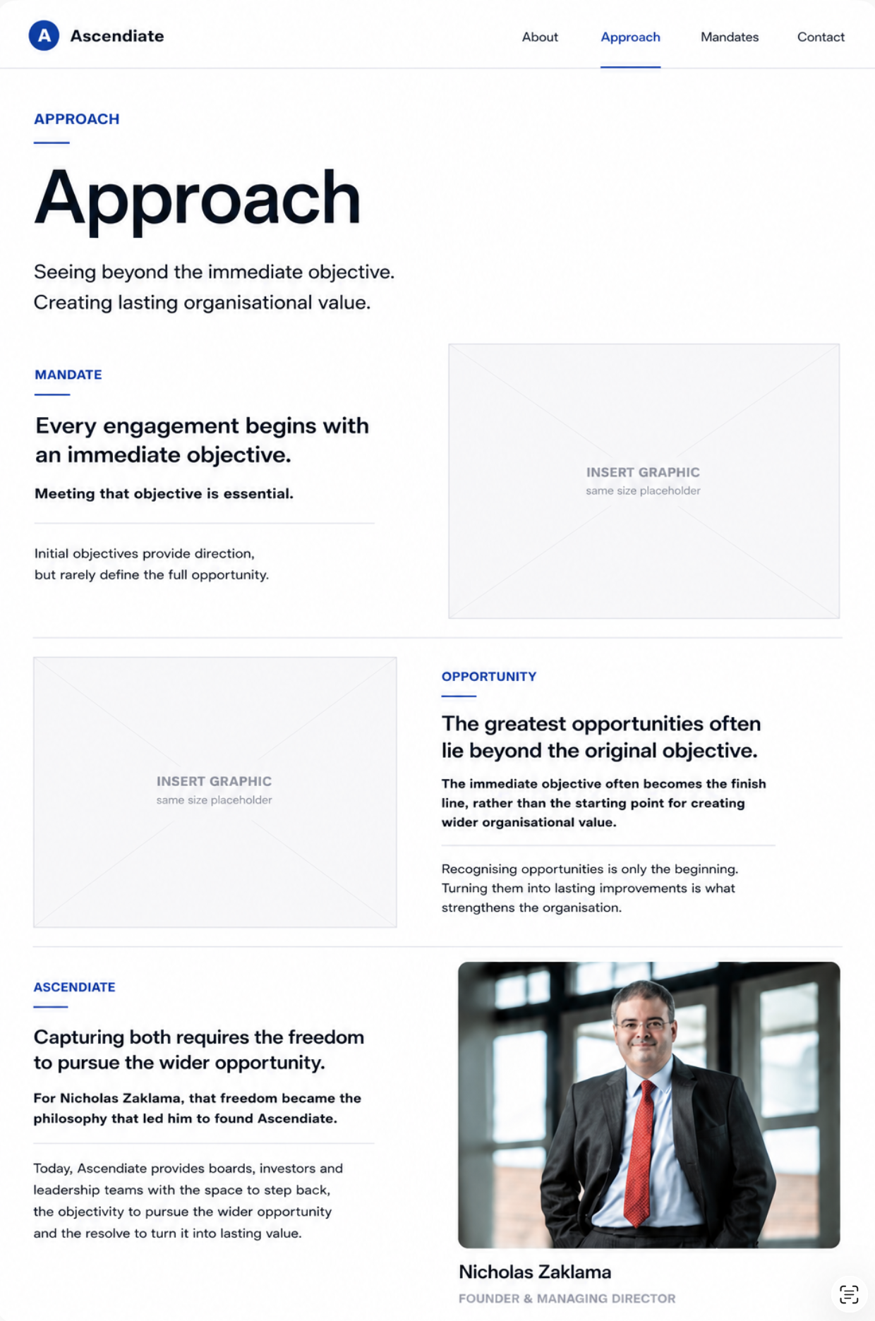
N.B. Intended to communicate hierarchy, composition and editorial rhythm only. They are not intended to prescribe typography, spacing, imagery or final design
MANDATES SECTION

General
- I think this section has the potential to become the visual centrepiece of the website.
- Whilst the underlying content is strong, the current presentation does not yet communicate the section as one coherent proposition.
- The objective should be to demonstrate why organisations repeatedly entrust Ascendiate with their most important mandates rather than simply describe what those mandates involved.
Positioning
- This section should communicate trust through evidence.
- Rather than presenting six unrelated examples, I would like the reader to experience the section as six pieces of evidence supporting one central proposition.
- The overall impression should be that organisations repeatedly entrusted Ascendiate with high-value, high-consequence mandates because of the judgement, integration and commercial outcomes delivered.
Presentation
- I do not think six equal cards or boxes create the strongest editorial presentation.
- Instead, I would like the section to feel more like a premium editorial composition than a conventional portfolio.
- The eye should be drawn towards a central visual anchor before naturally exploring the surrounding examples.
- The supporting examples should not appear as six independent cards or portfolio items. Instead, they should read as six pieces of evidence supporting one central proposition, with the central image acting as the organising visual element and unifying the overall composition.
- White space should play a significant role in establishing clarity, hierarchy and a calm reading experience.
- Similar to the About section, typography should remain the dominant design element throughout.
- Please see rough visualisation below.
Content

Headline
- Delete: Experience
- Replace with: Mandates

Lead statement
Add: Trusted where outcomes matter most

Supporting statement
Keep: Creating, preserving and unlocking value

Supporting examples

Note: The following wording should be regarded as content rather than layout. Typography, hierarchy, spacing and editorial presentation should be developed independently to create the strongest possible reading experience.

Enabled IPO readiness  Restructured USD4bn across 24 facilities with 14 lenders  Prepared a leading Middle Eastern airline for IPO | IMAGE | Achieved 20% portfolio growth  Expanded a publicly listed aircraft lessor’s portfolio by USD300m  Structured 11 aircraft investments involving 8 customers and 7 lenders
Preserved business continuity  Directed a USD1.1bn restructuring and refinancing across 12 lenders  Stabilised a publicly listed company throughout COVID-19 |  | Improved cash collection by 70%  Accelerated cash collection by over 70%  Transformed payment operations for an investment-grade enterprise.
Optimised hedging strategy  Delivered c.USD300m of fuel hedging savings  Strengthened treasury capability for a leading Middle Eastern airline |  | Shaped a USD1.25bn takeover bid  Directed transaction structuring and risk evaluation for a private equity consortium  Materially influenced the decision not to proceed

Editorial hierarchy
- Each supporting example should communicate a single commercial outcome before providing concise supporting evidence.
- The commercial outcome should become the dominant editorial element within each example.
- Supporting evidence should be significantly shorter than at present and exist primarily to reinforce credibility rather than explain the mandate.
- The overall objective should be that the section can be understood quickly whilst rewarding more detailed reading.
Imagery
- The imagery should not communicate industry, transactions or infrastructure.
- Instead, it should communicate the qualities that underpin the mandates themselves: structure, judgement, integration, complexity and direction.
- Rather than acting as decoration, I would like a single central architectural image to become the visual anchor for the entire section.
- The strongest visual references appear to be engineered architectural structures that communicate complexity resolved into one clear direction.
- The emphasis should not be on a particular structure (for example a bridge), but on the architectural qualities that such structures represent: structural integrity, convergence, perspective and destination.
- The overall impression should be that many complex elements have been resolved into one coherent outcome.
- Currently, I am particularly drawn to architectural imagery featuring strong symmetry, perspective and a visible vanishing point, as these naturally reinforce the themes of clarity, judgement and purposeful direction.
- The image should remain restrained and editorial in character, supporting rather than competing with the surrounding typography.
- The architectural image should be treated as an integral part of the editorial composition rather than as an illustration. The surrounding mandates should appear to support the image rather than compete with it for attention.
- The image should naturally become the first visual destination within the section, with the supporting mandates reinforcing rather than competing with that focal point.

Rough visualisation (idea only)
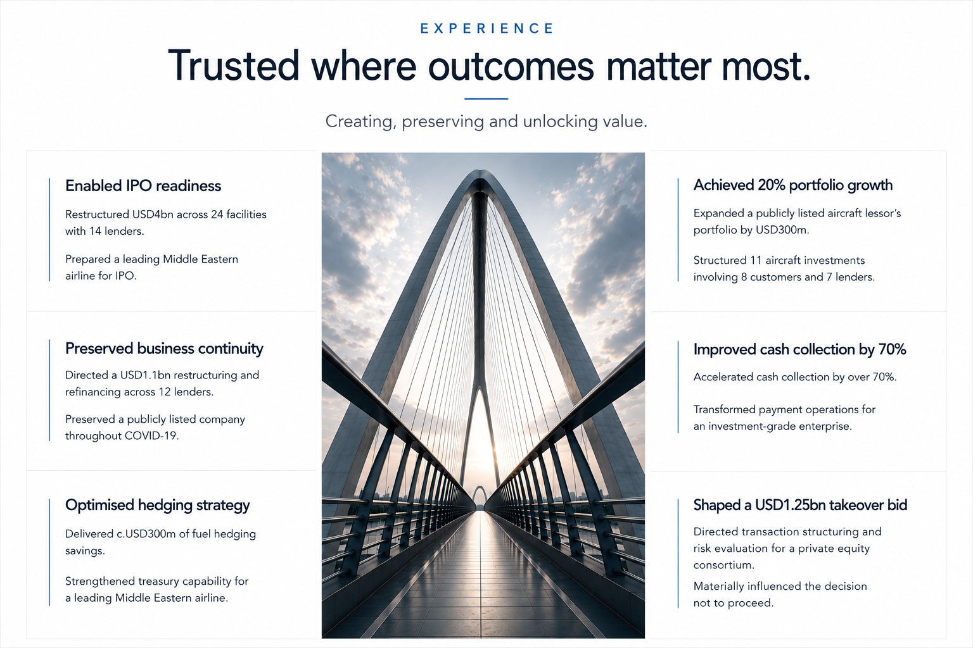
N.B. Intended to communicate hierarchy, composition and editorial rhythm only. They are not intended to prescribe typography, spacing, imagery or final design

CONTACT SECTION
- Please increase the typography for Contact, Address and related information so that it is consistent with the remainder of the website.
- The current size feels noticeably smaller and distracts from an otherwise consistent editorial hierarchy.

